Form Documentation

- AccountOwners

This form is used for access to the information of the account owners. This form can be used for searching, authenticating, modifying, or creating accounts. The form is split into different tabs for display of different account information.

Account Information
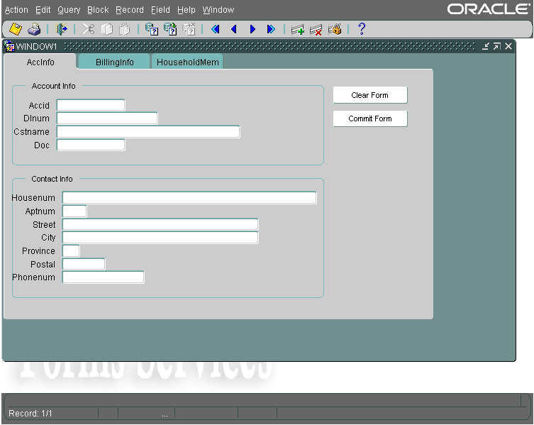
This tab is used to display the basic account information as well as the contact information for the account owner. Queries can be performed using the search buttons on the top tool bar. The two buttons on the side are used for account management. The Clear Form button will clear the form of any information currently being displayed. The Commit Form button will commit any changes to existing records, as well as commit the creation of new records.

Billing Info
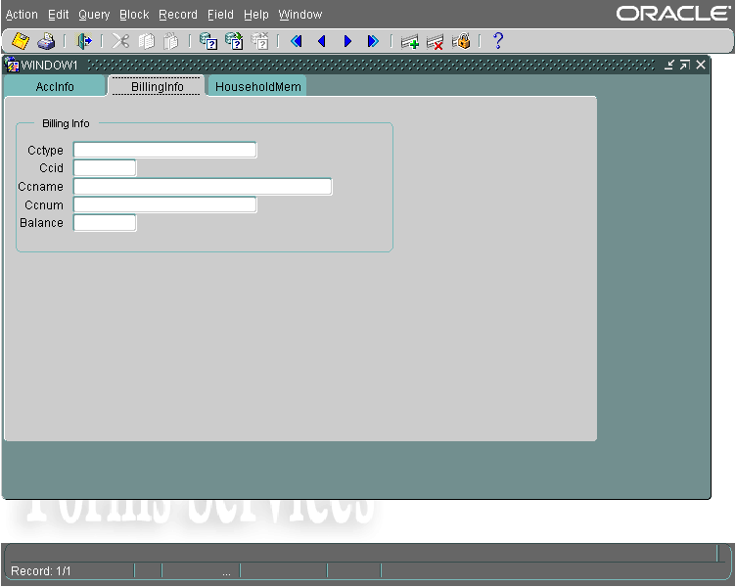
This tab is used to display, insert, and modify credit card information as well as the account owner’s current balance.

Household Members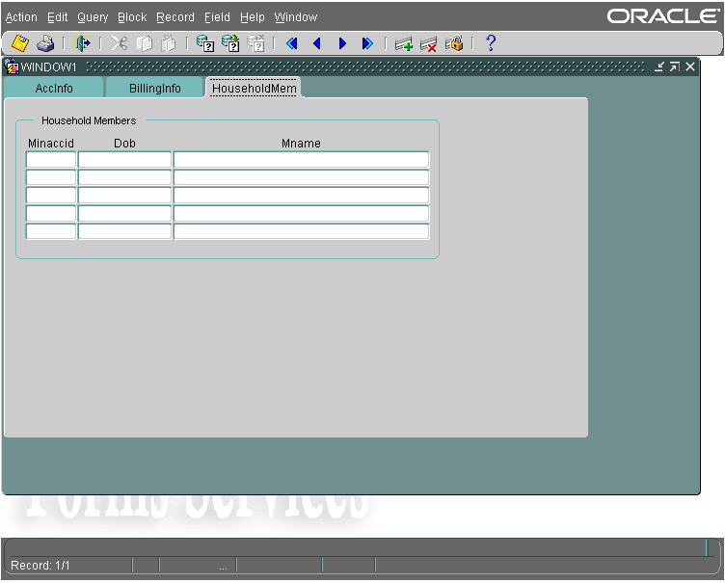
This tab is used to display, insert, and modify household members which can rent under the primary account owner.

- Employees

This form is used for access to the information of the employees. This form can be used for searching, authenticating, modifying, or creating employee accounts.
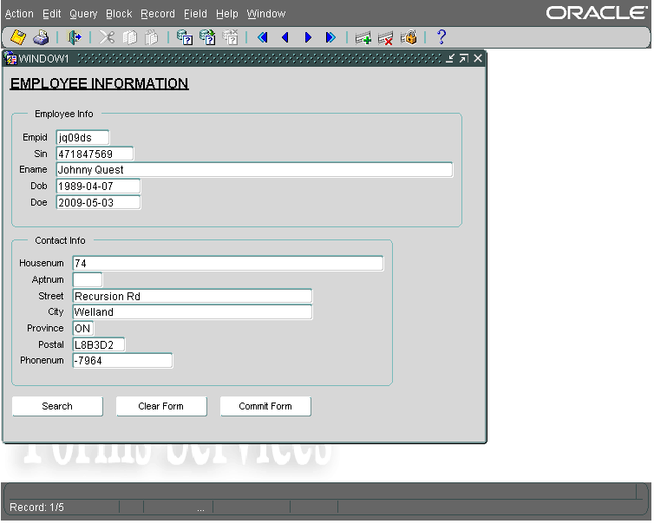
This form will display the Employee information as well as the Contact information for the chosen employee. The buttons along the bottom can be used for administrative purposes. The Search button can be used to query a specific employee. The Clear Form button will remove any data currently displayed on the form. The Commit Form button will commit any changes to existing records as well as commit the creation of any new Employee records.

- Transaction

The Transaction forms are where the majority of use will happen. The form can be used for the creation of transaction, as well as the addition of movie rentals, previously viewed purchases, and new movie purchases to the transaction.

Transactions
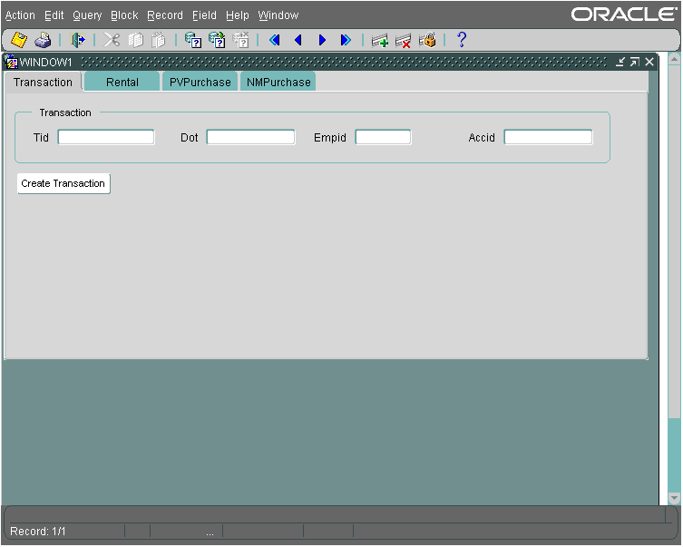
The transactions will be created in this tab of the form. The TID (Transaction ID), DOT (Date of Transaction), and EmpID (Employee ID) are required fields for the creation of a transaction, as AccID (Account ID) is not required if the transaction is for a movie purchase not a rental. The Create Transaction button on the button will commit the transaction into existence.

Rental
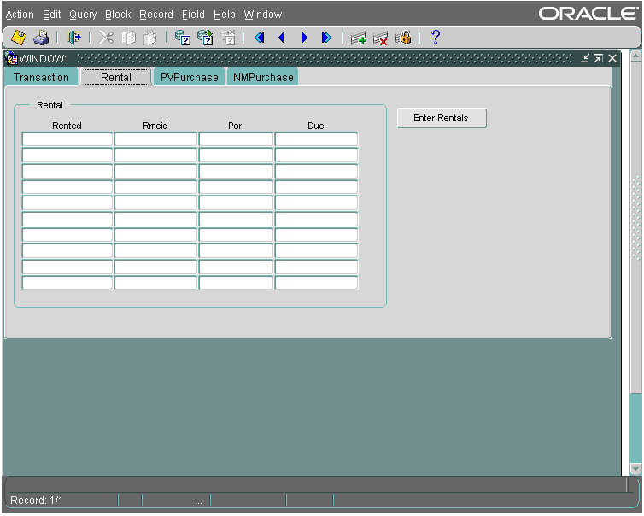
This form is used the addition of Movie Rentals to the transaction. The Rented column is filled with the Tranaction ID (TID), and the RMCID is the Rental Movie Copy ID, which is taken from the rented movie. When the Enter Rentals button is pressed, the rentals are commited to creation, and the POR (Price of Rental) and the Due date are automatically retrieved and displayed in the form.

Previously Viewed Purchase
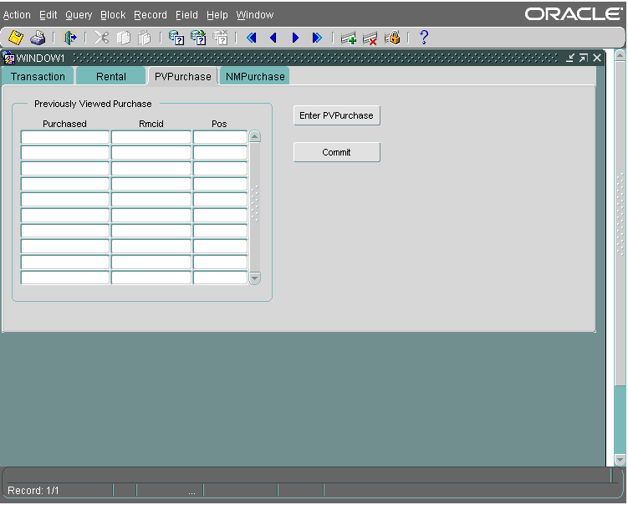
Movies which had been for rent but are now available for purchase are considered Previously Viewed movies. These can be added to the transaction here in the PVPurchase tab of the form. The Purchased column is entered with the Transaction ID, and the RMCID of the movie is entered. When the Enter PVPurchase button is pressed, the PVPurchase record is added to the transaction.

New Movie Purchase
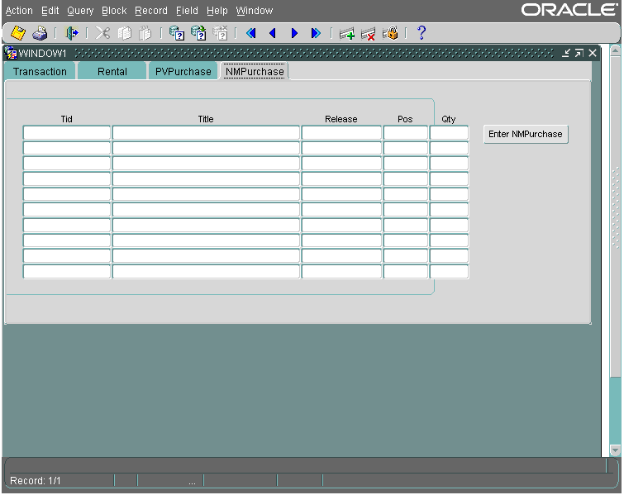
New movie purchases are added to the transaction here. The Transaction ID, Title, Release date, and quantity of the movie being purchased is entered into the form, and is added to the transaction.

- Rental Return
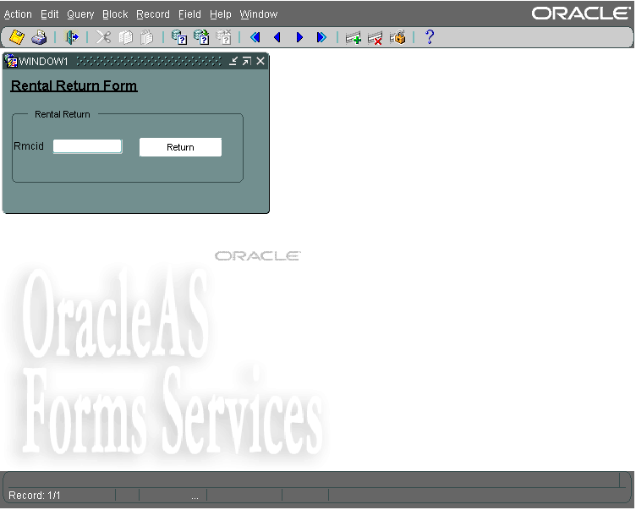
The returns of the rentals are handled by this form. The RMCID is entered into the form, and the Return button is pressed, returning the RMCopy to a rentable state.

- Movie Searching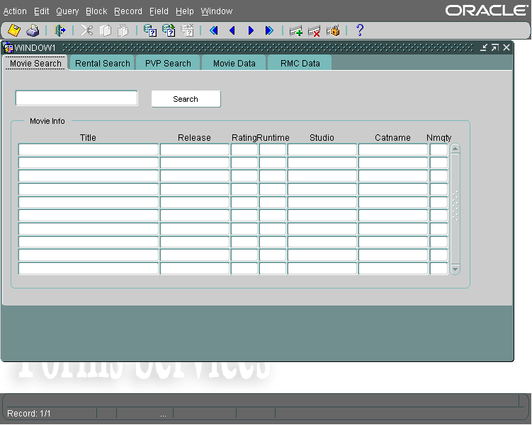

The movie searching form us used for searching for specific information based on movie title, or part of a movie title. The text is entered into the top search bar, and then the search button is pressed. This will bring up different information based on which search tab is selected. The Movie Search tab will bring up information on if the movie is in the movie database, as well as the amount of new copies for sale of each.
The Rental Search tab will do a search based on the movie entered if the movie is available for rental.
The PVP search tab will do a search based on the movie entered if the movie is available for purchase and is previously viewed.

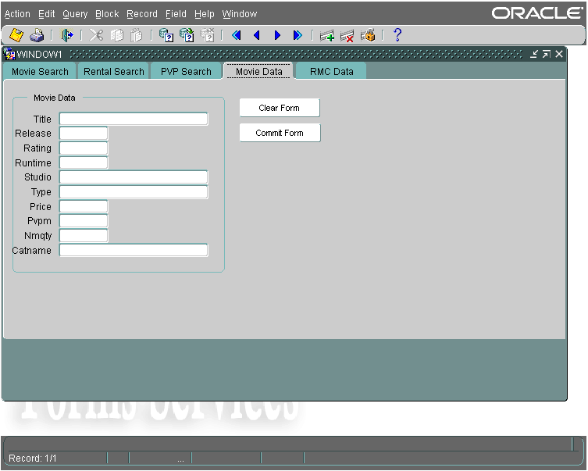
The Movie Data tab is used for the entry and modification of Movie Info records. A movie can be queried and modified, as well as a new movie record can be created.
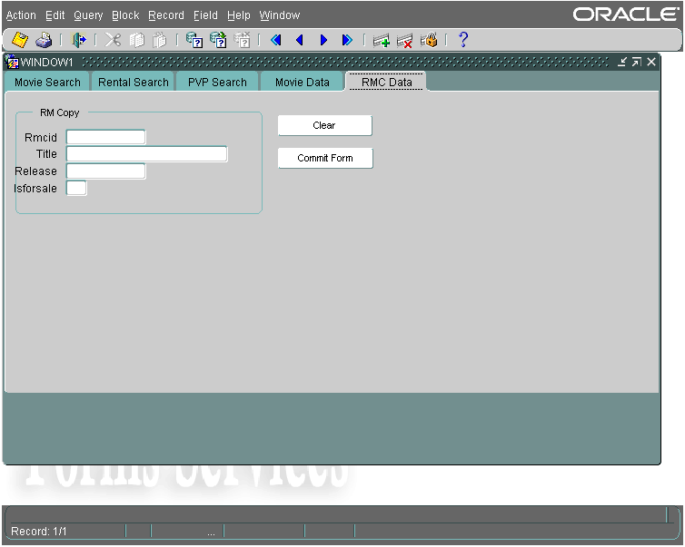
The RMC Data tab (Rental Movie Data) is used for adding copies of a movie to rental. The RMCID, Title, and Release are entered into the RMCopies records, as well as the ability to choose if the RMCopy is for sale or not.

